Assignment 12-11-2020

Name – Archisman Roy

CSE 2nd year 3rd sem

Roll - 50

1. Write a program to count the number of words, vowels, consonants and punctuations in a given sentence.

Ans.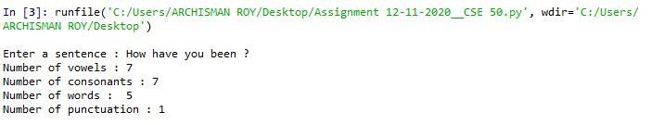

1. Write a program to print all non Fibonacci numbers within a range.

Ans.

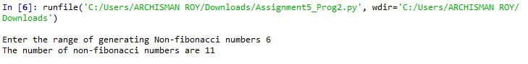

c) Explain the output of the following snippet, if the inputted value is

25.

x=input(“Enter a number: ”)

print(x\*3)

Ans. The output would be 252525. We are not converting “x” from string to integer , so it is printing “x” thrice.

d) Explain, with an example, how an equivalent of switch case be

implemented in Python.

Ans. There’s alternative method for switch case in python. We can use the switcher dictionary to overcome this.

def week(i):

switcher={

0:'Sunday',

1:'Monday',

2:'Tuesday',

3:'Wednesday',

4:'Thursday',

5:'Friday',

6:'Saturday'

}

return switcher.get(i,"Invalid day of week")